**Year Plan in fysik kemi grade 8 2023 2024**

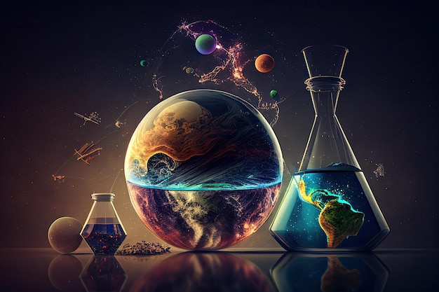

|  |  |
| --- | --- |
| **Topic** | **Week number** |
| **Electricity and Magnetism** |  |
| Static electricity. Introduction to charge | 32 |
| Circuits and terminology: current, potential difference and how they behave in series, and parallel circuits | 33 |
| Resistance and ohms law | 34 |
| Effect and units | 35 |
| Magnetism: permanent and electric | 36 |
| Magentism: permanent and electric | 37 |
| Induction. Turbines and generators  Frequencey. Units and how it relates to electricity | 38 |
| Transformation  Producing electricity: various methods Project work with demonstrations  Kilowatt hours | 39 |
| Producing electricity: various methods. Project work with demonstrations. | 40 |
| fællesforløb | 41 |
|  | 42 half term |
| fællesforløb | 43 exams |
| **Cycles in Nature** |  |
| Water Cycle | 44 |
| Nitrogen Cycle | 45 |
| Carbon Cycle. Recap on photosynthesis | 46 |
| **Waves and Radiation** |  |
| Properties of waves  Sound waves. Define and uses | 47 |
| Sound waves. Define and uses  Light waves. Properties. | 48 emneuge |
| Light waves. Properties. | 49 |
| What is light? EM spectrum  Where does light come from. Bohr’s model | 50 |
| Waves in real life and extension work   * Relativity * Tidal waves | 51 |
| **Climate Change** |  |
| Greenhouse effect  Global warming and consequences  Causes of greenhouse gases. The role electricity production, food, transport play | 2 |
| Greenhouse effect  Global warming and consequences  Causes of greenhouse gases. The role electricity production, food, transport play | 3 |
| Effects on weather (Geo) and life (Bio) | 4 |
| Distilling of oil. Link to Biology and Geography  Polymers and plastics | 5 |
| Distilling of oil. Link to Biology and Geography  Polymers and plastics | 6 |
| Holiday | 7 |
| Fælles forløb | 8 |
| Fælles forløb | 9 |
| **Energy** |  |
| Energy types and changes | 10 |
| Energy laws and efficiency | 11 |
| Heat. Conduction, convection radiation   * Albedo effect * Desinty | 12 |
| * Heat. Conduction, convection radiation * Albedo effect * Density | 13 |
| Weather and how it is affected by differences in heat | 14 |
| Golf stream: How it works and role it plays | 15 |
| fællesforløb | 16 |
| fællesforløb | 17 |
| fællesforløb | 18 |
| **Metals and ions** |  |
| Define, and ionic bonding  Flame tests | 19 |
| Properties | 20 |
| Bonding: intro to covalent bonding | 21 |
| Covalent bonding: recap on polymers in general | 22 |
| Test | 23 |
|  | 24 |
|  | 25 |
|  | 26 |