**4th grade English Yearly Plan**

CCS 2024-25

Nancy Staur

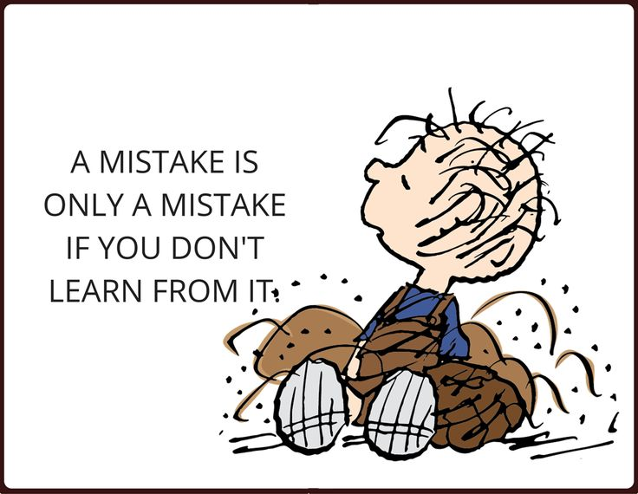

My focus is on making English,a subject that our students really enjoy and look forward to improving in. Therefore, my teaching style is strongly determined by the students’ interests, motivation, level and skills and so occasionally, some changes may occur in my planning when it fits the 4th grade students best.

My plans and goals for my 4th grade students focus on teaching the requirements determined by “fællesmål” including some of these areas:

* Develop the students’ vocabulary by reading and discussing various texts, in class.
* Spelling will be practiced using words from the texts and themes we are working on. My experience has shown me that spelling correctly boosts both their confidence in writing and aids in their pronunciation and even interest in learning more words.

Dictations will be given every other week and students will be reminded one week in advance.

* Focusing on grammatical areas by discussing grammar in class and practicing grammar in the form of games and by completing grammar book assignments often from “legoglektie” Writing grammatically correct sentences with a length of minimum 6 or more words and using various word classes in their writing.
* Provide many opportunities to discuss and share their ideas in the form of oral presentations and during small group activities. Focus on improving pronunciation, vocabulary and confidence in doing presentations.
* Be active in speaking English with everyone in class by using “Cooperative learning activities” which are used throughout the year. (Note: Occasionally- I will be writing home to ask for certain household items needed for the lessons.)
* I use” differentiated instruction”and typically my students will be seen doing various activities that develop different skills using various tasks based upon on their level, speed and abilities. For me it’s a challenging way of teaching but I find, it keeps the students active and often maintains their motivation.

**Materials**

I use a variety of materials and some texts from various textbooks,(so no one textbook is used) and of course, the internet, CFU novels, films and online materials from Gydendal Engelsk mellemtrin . Using Gydendal’s Readers opens up a variety of various stories and texts that I will be using in my lessons and encouraging my students to use in their free time. *My yearly plan is organized with a focus on specific themes however, as new ideas and novel materials are discovered during the year, some changes could occur with my timeline.

|  |  |  |  |  |
| --- | --- | --- | --- | --- |
| **Måned/Tema** | **Forløb** | **Kompetence-områder** | **Mål** | **Supplerende materialer** |
| **August/September**  Our Identity  Our Families  Bulllying | **“Dr. Seuss- The Cat in the Hat”**  Få The Cat in the Hat af Dr Seuss som ...  **“The Bear that Wasn’t”**  **Bio-digte** | Mundtlig kommunikation og sproglig fokus  Skriftlig kommunikation  Kultur og samfund | Eleven kan kort fortælle om sig selv  Eleven har viden om ord og fraser til at præsentere sig selv.  Eleven kan lege med Engelsk skriftsprog og har viden om enkelte sætninger  Eleven har viden eventyr, tegneserier, sange, rim og remser | ”Egghead” Mit CFU ankommer d. 19 august – 9 september  “**This is how we do it”**  (Mit CFU)  one day in the lives of seven kids from around the world  [af Matt Lamothe](https://mitcfu.dk/samling.aspx?mode=-1&page=1&search=person:%20Matt+Lamothe)  **Indholdsbeskrivelse:** Denne flotte billedbog beskriver 7 autentiske familiers hverdag, fortalt gennem 7-11 årige børn. |
| **September**  **Fairy tales**  **Grammar** | [FAIRY TALES](https://engelsk4-6.gyldendal.dk/topics/fairytales) * [4. The Golden Goose](https://engelsk4-6.gyldendal.dk/topics/fairytales/kapitler/famous_fairy_tales/the_golden_goose) * [5. Jack and the Beanstalk](https://engelsk4-6.gyldendal.dk/topics/fairytales/kapitler/famous_fairy_tales/jack_and_the_beanstalk)   See the two unit plans:  Little Red Riding Hood  Alice in Wonderland    <https://kp.mitcfu.dk/44977680>    <https://kp.mitcfu.dk/50933334>  GRAMMAR: VERBER ([PRÆSENS](https://engelsk4-6.gyldendal.dk/language/grammar/verber/tider/praesens) OG [PRÆTERITUM](https://engelsk4-6.gyldendal.dk/language/grammar/verber/tider/praeteritum)) | **Mundtlig kommunikation: præsentation**  **Skriftlig kommunikation:**  **læsning** | **Sproglig fokus:** Eleven kan forstå de hyppigste ord og fraser inden for nære emner  **Lytning:** Eleven kan forstå hovedindholdet i korte fortællinger.  **Sprogligt fokus**: Eleven kan anvende enkle nutids- og datids former.  Eleven har viden om enkelte bøjningsformer af udsagnsord. | READERS: [JACK AND THE BEANSTALK](https://i-bog.gyldendal.dk/07a100b5-04ec-4025-b357-b2e1411d1f6c#/) |
| **October/November**  **Ghosts**  Halloween  Wizards and Witches | Ghost Images - Free Download on Freepik  Link to Ghost-forløb:  [https://engelsk4-6.gyldendal.dk/topics/ghosts/kapitler/start/for_the_teacher](Link%20til%20forløb%20på%20Gyldendal%20om%20Ghosts) GRAMMAR  1. First, find all the verbs in the present and the past tense. [Read about the present tense here.](https://engelsk4-6.gyldendal.dk/language/grammar/verber/tider/praesens) [Read about the past tense here.](https://engelsk4-6.gyldendal.dk/language/grammar/verber/tider/praeteritum) [Find all the verbs in the text here.](https://engelsk4-6.gyldendal.dk/learningObject/b88ef0a1-3d3d-4ee1-86eb-9c5d406c1428) 2. Now, look at the text again with a partner. Can you explain why some verbs are in the present tense and some are in the past tense?   Halloween | Eleverne arbejder selvstændigt med forløbets centrale ordforråd i tre dele:  Presentation  Practice  Production: | Det nye ordforråd præsenteres i form af flashcards (oversættelser + udtale).  Eleverne arbejder med en række træningsopgaver, hvor lytte-, læse- og skrivefærdigheder kommer i spil.  Eleverne påbegynder arbejdet med deres egne ordlister, hvor nye ord og vendinger skal oversættes, sættes ind i en sammenhæng og kategoriseres grammatisk. | READERS:  [HALLOWEEN](https://i-bog.gyldendal.dk/644e9164-15d0-4d0f-ba17-63ba90742735#/?view=default&page=1)  From Gyldendal Engelsk mellemtrin  ”The babysitter story- an urban legend” VIP TEXTS af Vibeke Flemmer og Lene Juul |
| **November**  Charlottes Web | CHARLOTTE'S WEB | Dallas Children's Theater  Read the novel and discussing the themes in class.  GRAMMAR: Focus will primarily be on adjectives | Mundtlig kommunikation  Skriftlig kommunikation | Lytning: Eleven kan forstå korte instruktioner, spørgsmål og beskrivelser  Samtale: Eleven kan stille og besvare enkelte spørgsmål ved hjælp af faste fraser.  Sprogligt fokus;: eleven har viden om ordklasserne.  Læsning; Eleven kan forstå hovedindholdet af enkelte tekster | Charlotte’s web book |
| **December**  **LET´S CELEBRATE** | [LET’S CELEBRATE](https://engelsk4-6.gyldendal.dk/topics/lets-celebrate) | Mundtlig kommunikation:  lytning  Mundtlig kommunikation: samtale | Eleven kan forstå korte instruktioner, spørgsmål og beskrivelser.  Præsentationer: Eleven har viden om støtteteknikker til præsentation.  Eleven har viden om beskrivende sprogbrug. | EXTRA:  [CHRISTMAS ACTIVITIES](https://engelsk4-6.gyldendal.dk/teacher/faglig_inspiration/christmas) |
| **January/februrary**  **Cowboy Country** | Western Wanted Skilt  Vocabulary with the theme  Oral presentation skills  Square Dance  Working on reading and discussing texts. | Mundtlig Kommunikation  Skriftlig kommunikation  Kultur og Samfund | Lytning: Eleven kan forstå hovedindholdet i korte fortællinger  Samtale*: Eleven kan deltage i enkelte spontane samtaler  Skrivning : Eleven kan kommunikere med enkelte ord og korte sætninger  Interkulturel kontakt: Eleven kan deltage i lege og sange fra engelsksprogede lande. | .Nancy will find add’l texts here. |
| **Marts**  **USA** | USA map with states and capital cities ...  Intro to the theme USA use following link: https://tidslinjer.gyldendal.dk/layouts/laytimeline.aspx?id={5C7707EA-3C48-4966-BDCE-0482D8734FEB} | Mundtlig kommunikation  Skriftlig kommunikation  Kultur og samfund | Præsentation: Eleven kan forstå hovedindholdet i korte fortællinger  Sproglæringsstrategier: Eleven kan overføre sprog, indhold og struktur fra det mundtlige til det skriftlige arbejde.  Engelsk som adgang til verden: Eleven har viden om steder, hvor der bruges engelsk. | Schools in USA:  https://engelsk4-6.gyldendal.dk/topics/schools-in-the-us |
| **April/Maj**  **Take it outside** | Take It Outside | Engelsk 4-6 ...  Link til forløb: <https://engelsk4-6.gyldendal.dk/topics/take-it-outside> | Skriftlig kommunikation,  Mundtlig kommunikation til præsentation." | Skriftlig kommunikation,  Mundtlig kommunikation til præsentation."  Eleven kan anvende relevant ordforråd til at beskrive udseende og tekstur. (skrivning)  Eleven kan give en kort mundtlig præsentation af et selvvalgt område på skolen. (præsentation) |  |
| **June**  **Culture /Denmark**  **Summerbreak** | **Alinea engelsk mellemtrin**  Amalienborg Castle Copenhagen | Denmark ...  Project: “**Being A Tourist in Denmark”**  In small groups the students have prepared information that they present about a building, area or important tourist place that is important to visit if in ‘Denmark.  We visit the places together and hear the presentations. | Mundtlig kommunikation  Skriftlig kommunikation | -Eleven kan med støtte kort tale om nære og faktuelle emner    -Eleven har viden om støtteteknikker til præsentation  -Eleven kan fortælle om egne traditioner og egen dagligdag.  -Eleven kan skrive enkle informerende tekster  -Eleven har viden om enkle rubrikker, billeder, diagrammer og grafik som støtte til præsentation,  kultur- og samfundsgrupper | Nancy will find add’l texts here. |