**Year Plan fysik kemi grade 9 2023 2024**

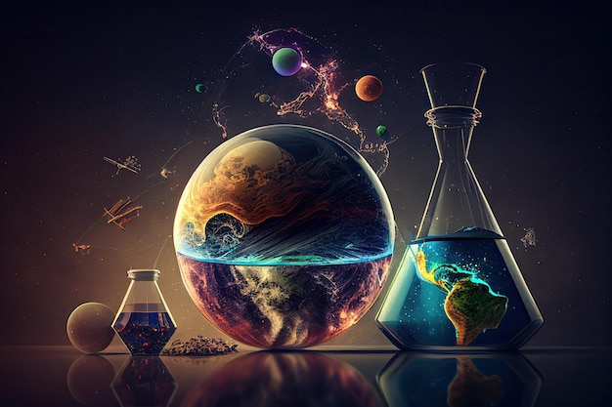

|  |  |
| --- | --- |
| **Topic** | **Week number** |
| **Radioactivity** |  |
| Introduction. The history of radioactivity | 32 |
| Properties of 3 kinds, atomic reactions for 3 kinds. | 33 |
| Experiments related to properties. Penetration. Background radiation | 34 |
| Ionising radiation and health. Uses of radioactivity. Risks of radioactivity. Experiments linked to this theme. | 35 |
| Half life. Uses and modelling. | 36 |
|  | 37 London |
| Nuclear energy. Advantages and disadvantages. The role it could play in climate change. | 38 |
| The role of radioactivity in the Earth’s history. Albedo effect, and how volcanic activity created the greenhouse effect. | 39 |
| Earthquake in Japan  Waves  Radioactivity  Linked to volcanic work in geo | 40 |
| Exam and fællesforløb in 2 areas: consider earthquake in Japan, sustainable production of energy, climate change in relation to pollution | 41 |
|  | 42 half term |
|  | 43 exams |
| **A Journey to Space** |  |
| A trip to mars intro  Defining force, speed and acceleration.  Force Diagrams  Newton’s 3 laws | 44 |
| Newton’s 3 laws, weight and mass | 45 |
| Gravity. Free fall.  Atmospheric pressure define.  Atmospheric pressure on Mars, and issues this causes. For example, sublimation of water. | 46 |
| Terraforming Mars. Issues relating to magnetic field, water, pressure, travel, greenhouse effect, fertile soil. | 47 |
|  | 48 emneuge |
| Test and fælles forløb | 49 |
| Test and fælles forløb | 50 |
| **Metals and Ions** |  |
| Metals and ions.  Recap on bonding | 51 |
| Exams | 2 |
| Metals’ properties  Metals in use  Electricity and metals with recap on electricity. | 3 |
| Covalent bonding  Electrolysis  Electricity and metals with recap on electricity.  Manufacturing metals | 4 |
| **Climate Change** |  |
| Recap on waves  Greenhouse effect | 5 |
| Global warming and consequences  Effects on weather (Geo) and life (Bio) | 6 |
| Holiday | 7 |
| **Energy** |  |
| Energy: Types and energy changes, and laws. | 8 |
| Heat, and how heat moves. Density.  Weather and how this is driven by differences in heat. | 9 |
| Golf stream how it works. Modelling of. Link to climate change. | 10 |
| Fællesforløb on climate change in Greenland | 11 |
| Fællesforløb on climate change in Greenland | 12 |
| Fællesforløb on Earhquake in Japan: Linking work on waves, geography, radiation, and biology | 13 |
| Fællesforløb on Earhquake in Japan: Linking work on waves, geography, radiation, and biology | 14 |
| **Fossil Fuels and Polymers** |  |
| Distilling of oil. Link to Biology and Geography  Polymers and plastics | 15 and 16 |
| Used as recap on material if time allows | 17 |
| Used as recap on material if time allows | 18 |